CFO Portrait

Robert Horvath – Visionary & Financial Expert
CFO of Hödlmayr International GmbH

After completing his secondary education in mechanical engineering, Robert Horvath studied at the Steyr University of Applied Sciences and completed his MBA at LIMAK. He began his professional career at Porsche AG Stuttgart. This was his entry into the automotive industry, which would henceforth accompany him in a wide variety of positions throughout his professional career. Starting in 2006, he worked for Rübig GmbH for over 14 years, most recently as Holding Managing Director. Under his leadership, the Group was able to increase its sales to 70 million and increase its workforce from 150 to over 500. With a strong focus on transformation, he succeeded in internationalizing a small and medium-sized business into a globally active group of companies with the establishment of new branches in Germany, Slovakia, China and the USA.

Since July 2020, Robert Horvath has been contributing his expertise as CFO and Member of the Management Board to Hödlmayr International GmbH. In his role, he is responsible for Finance, Controlling, Legal, Human Resources, IT, Purchasing and Corporate Social Responsibility, as well as Marketing & Communications.

Robert Horvath has a partner and is the father of two children. He spends his free time with his family, or in regatta sailing, skiing and endurance sports. As a life-long learner, he expands his horizons by traveling and reading a variety of books in the field of leadership and management. His motto: “Going the extra mile - there is always a solution.”

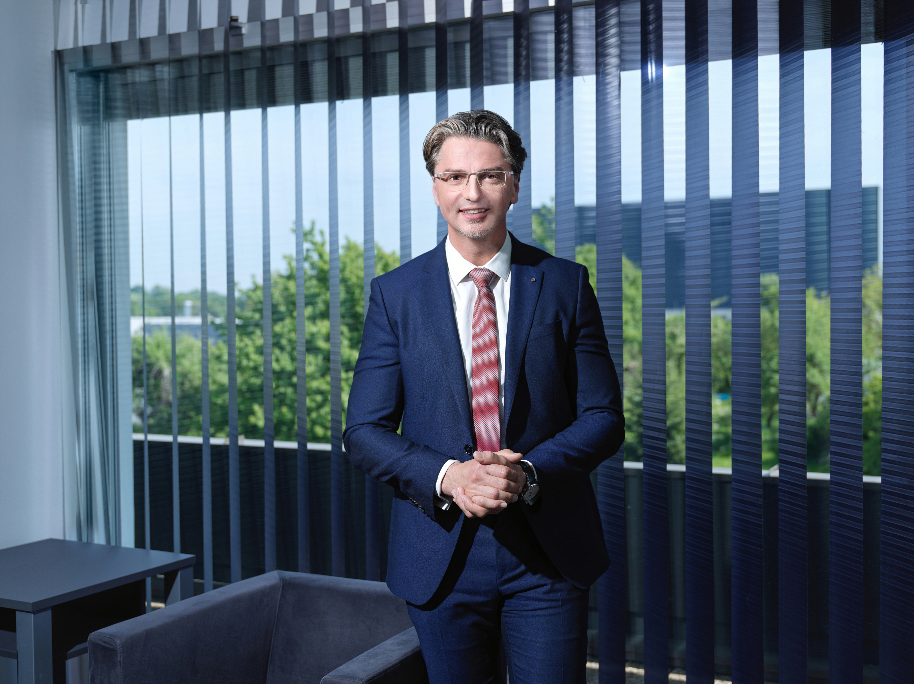

© Hödlmayr International GmbH
Robert Horvath, CFO Hödlmayr International GmbH

