COO Portrait

Andreas Sundl – strategist and logistics expert
COO Hödlmayr International GmbH

Andreas Sundl has been COO and member of the Management Board of Hödlmayr International GmbH since July 1, 2021. In his role, Andreas Sundl is responsible for the operational agendas as well as the overall international sales activities.

His career at Hödlmayr began in 2007. Since then, he has passionately and successfully acted as Managing Director of the branches in Austria, Germany and the Czech Republic. Since 2017, Andreas Sundl has also been Managing Director of Hödlmayr Rail GmbH. Under his leadership, he succeeded in building a stable organization and dedicated managers. This has enabled the companies to make a significant contribution to the overall success of the Hödlmayr Group.

Prior to Hödlmayr, he worked in various roles in ÖBB and Rail Cargo Austria. At the end, Andreas Sundl held the position of Managing Director of Car Rail Logistics, a joint venture of ÖBB and Hödlmayr. Born in Graz, he attended the public Stiftsgymnasium Melk grammar school and then trained as a dispatcher in the operating department of the ÖBB.

Andreas Sundl is married and is the proud father of two children. He spends his free time with his family and his two dogs. You can also meet him at the golf course, sailing, mountain biking, or with a book. Ask him for a good book or restaurant tip. His motto: “You can’t change the wind, but you can change the sails.” – Aristotle

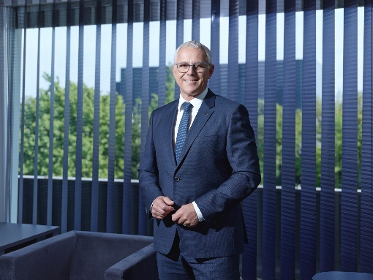

© Hödlmayr International GmbH
Andreas Sundl, COO Hödlmayr International GmbH

